21st December 2016

**Success for Yokohama Italy at the Bologna Motor Show**

Yokohama Italia, recently took part in the most important festival within the Italian Motorsport scene.

The last weekend of the show, produced exciting duels within the racing section known as “Area 48” at the Bettega Memorial race that traditionally concludes the exhibition.

With over 225.000 people attending the fair in Bologna, YOKOHAMA was a firm favourite among motorsport fans who appreciated the very visible road side branding and video displays at the fair’s main entrance and inside the Motorsport arena.

In addition to this important event during the course of the past weeks, YOKOHAMA Italy has taken part in numerous other Motorsport competitions with significant success.

At the Trofeo Rally Terra, YOKOHAMA managed the victory with Pablo Biolghini on a Skoda R5 and the good experience of Giuseppe Bergantino who was driving on dirt track for the first time on YOKOHAMA and managed a very worthy third place in the podium on the R5 Trophy on a Ford Fiesta R5.

For his part Giuseppe Pezzaioli, Motorsport Manager of YOKOHAMA Italy expressed satisfaction with the show and highlighted the strong technical presence of YOKOHAMA at this year’s edition. “I sincerely hope that the Motor Show, which represents the history of the engines in Italy, can positively pursue this new path and I take this opportunity to thank all the drivers who have been using YOKOHAMA tyres throughout the 2016 season in the different categories. He concluded.

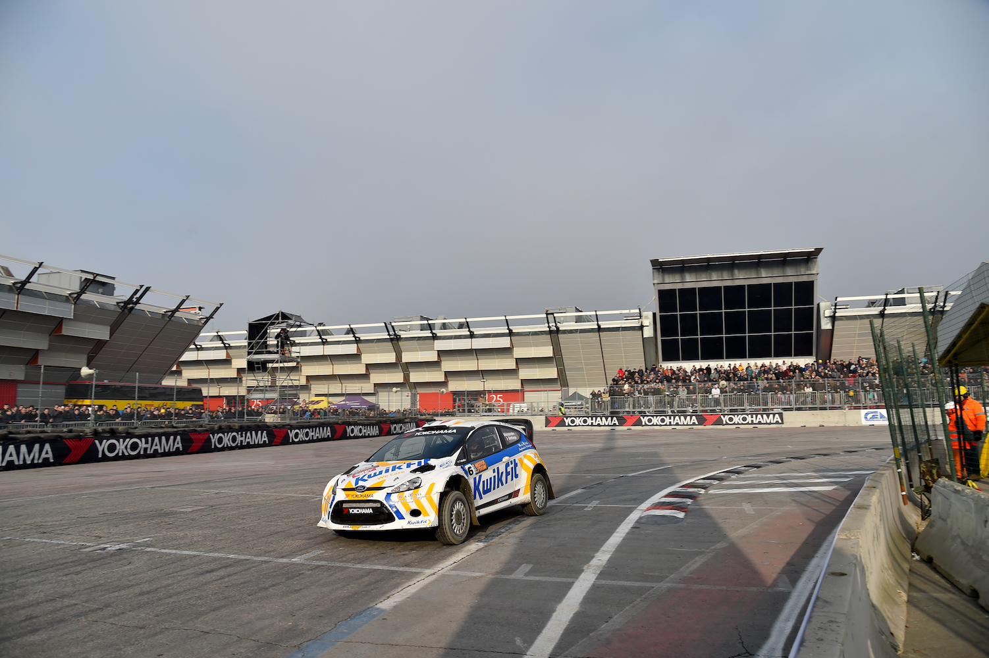

*YOKOHAMA participation at Bologna Motor Show*

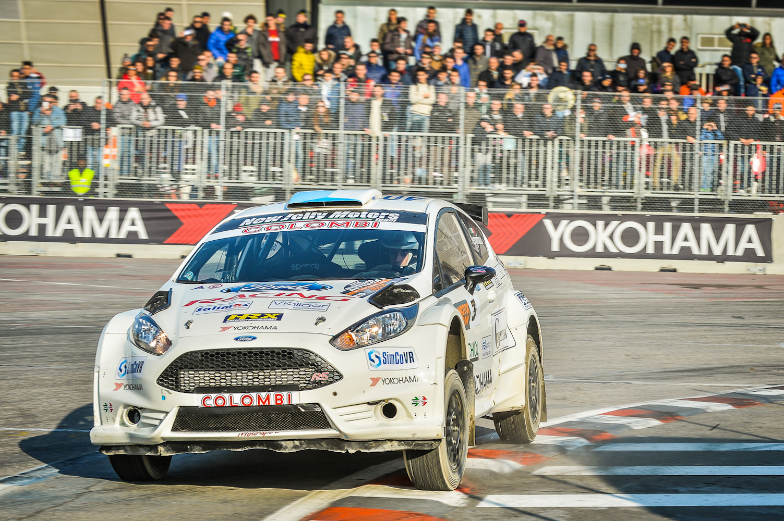

*YOKOHAMA at Motor Show*

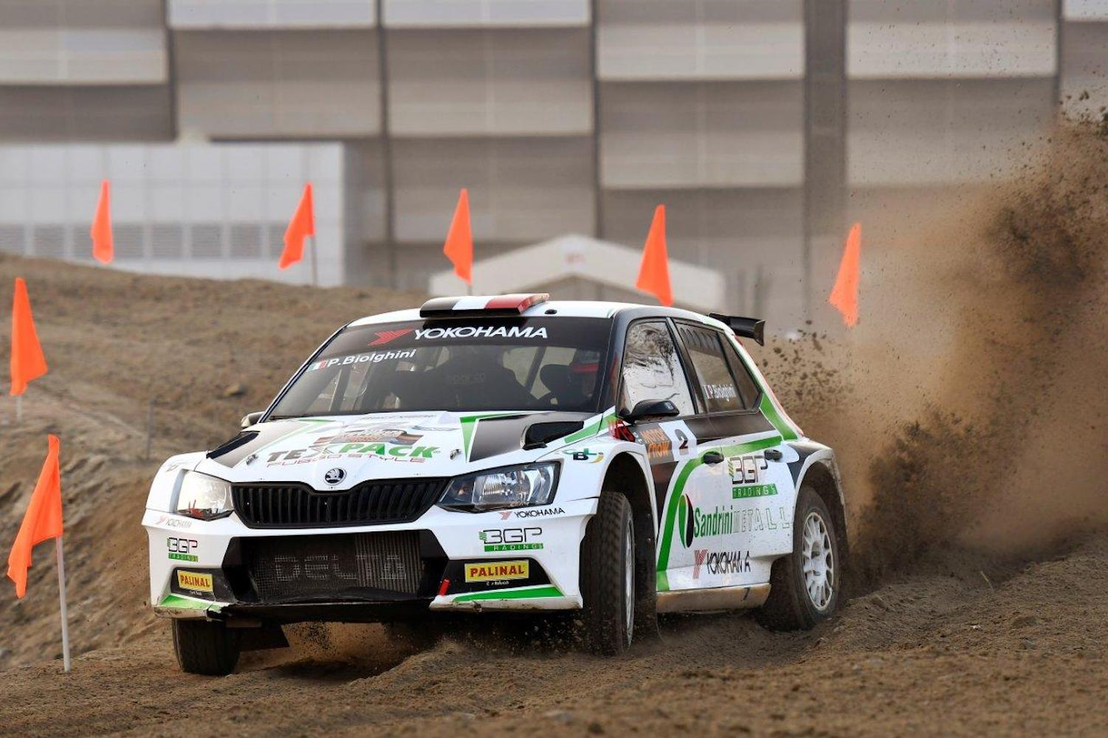

*Biolghini wins for YOKOHAMA*